ASNT_PRBS20D_V2
PRBS9/10 Generator Featuring Jitter Insertion, Selectable Sync, Output Amplitude Control and USB Control

- Broadband operation from 20Mbps – 22.0Gbps
- Fast rise and fall times
- Two PRBS data outputs with output amplitude control
- Up to 140ps delay variation on each output
- Built-in Programmable Clock Generator
- External high-speed clock input capability (AC-coupled on board)
- Differential high-speed clock output
- 50% duty cycle for sync output on all divide ratios
- USB Software GUI Control Interface via USB 2.0
- Single positive 5V supply

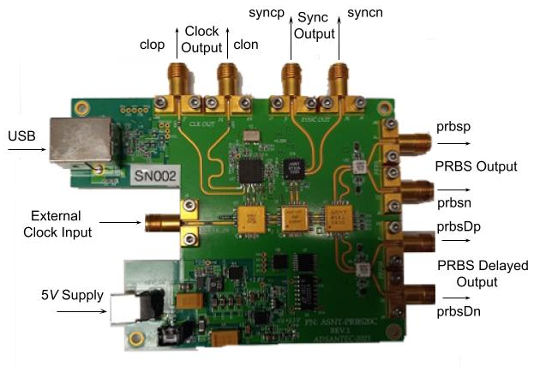

Fig. 1 ASNT_PRBS20D_V2 board

DESCRIPTION

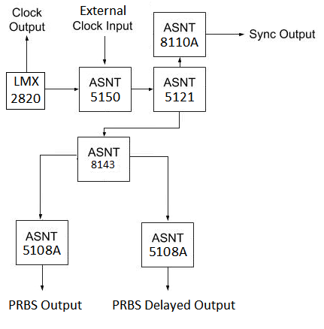
Fig. 2 PCB Block Diagram

The ASNT_PRBS20D_V2 is a broadband 2⁹-1, or 2¹⁰-1 PRBS generator intended for test, and prototyping of microwave communication applications. The board features a programmable clock synthesizer up to 22GHz, while also supporting an external clock input. The PRBS data amplitude is adjustable from 50mV to 800mV single-ended peak to peak, and its phase is adjustable up to 140ps for both differential outputs. A single-ended clock from 20MHz to 22GHz with an amplitude as low as 50mV peak to peak may be applied to the high-speed clock input. An independent differential clock output from the internal programmable clock generator is provided. A programmable differential Sync Output provides a divided copy of the input clock with a division ratio from 1 to 256. The Sync Output is mainly used to trigger a high-speed oscilloscope. The system is capable of triggering an eye diagram for PRBS9/PRBS10. The USB 2.0 port allows the board to connect to any compatible PC for a simplified software-based operation.

OPERATION
1. Measure 50Ohms on all SMA connectors referenced to VCC.
2. Connect the power supply (provided) to the board, and connect to any PC via an USB cable.
3. Install the included software on the connected PC following the software installation dialog box as shown in Fig. 3.
(This step will not need to be repeated unless switching PC’s).
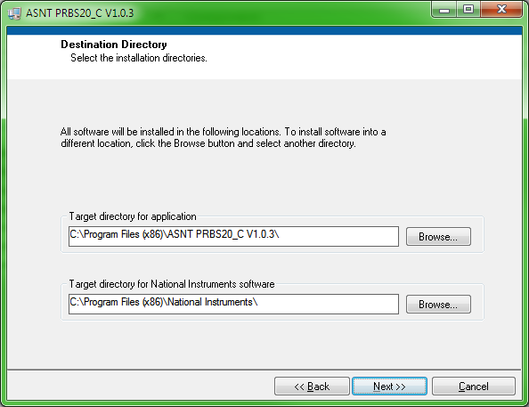
Fig. 3 Software Installation Dialog

4. After the installation is complete, initiate the GUI software and confirm its connection by ensuring that the USB Connection Indicator light is green as it’s depicted in Fig. 4.
5. The Clock Input Control can be used to select the use of either on-board synthesized, or externally generated clock when desired. If using an external input clock signal, a DC block is not required due to on-board integrated AC coupling.
6. Set the frequency as desired either via the software GUI, or through manipulation of the external clock signal.
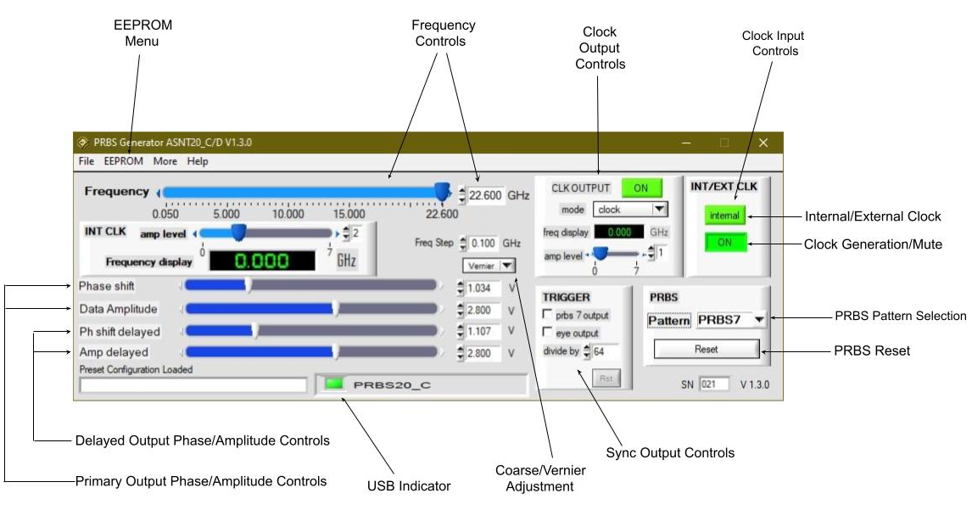
Fig. 4 Software GUI
NOTE: The latest software is now capable of auto-detection of the PRBS pattern types available and will change to PRBS20D upon connection of the USB cable once power is applied and the software is running.
7. The PRBS Selection/Reset Control can be used to select the desired output pattern (PRBS9/PRBS10), and to provide a PRBS reset when necessary (The board is equipped with automatic reset).
8. The Clock Output Control can be used to enable/disable the clock output from the built-in frequency synthesizer used for data generation. The amplitude of the output clock can also be controlled from here. Using the “mode” drop down window, the controls will allow for a divided clock output when desired. Note that these clock outputs are also AC coupled on-board.
9. The Sync Controls (Trigger) can be used to manipulate the division ratio used for the sync signal output; it can also be used to set a manual division ratio when desired. Note that the sync output does not provide a high enough division ratio to view PRBS9/PRBS10 output as a pattern; one data output can be divided by 256 or 512 respectively to view these patterns if necessary.
10. The Amplitude Controls (Data Amplitude and Amp delayed) can be used to adjust the amplitude of both the PRBS Output, and the Delayed PRBS Output. The Phase Shift (Phase Shift and Ph shift delayed) controls can also be used to adjust the phase of each data output by up to 140ps.
11. Configuration settings, by default, are saved to a cfg file within the installation directory; when desired, settings can also be saved (or loaded) directly from the EEPROM menu.

12. The PRBS Drift (Jitter Insertion) Controls can be used to inject jitter into the output signal if desired. The Step Value and Step Count can both be used to create jitter in different ways, or be used in combination, with higher values corresponding with greater inserted jitter. This option can be found under the “More” tab (labeled as Additional Controls in the diagram above).

ELECTRICAL CHARACTERISTICS
PARAMETER |  | MIN TYP MAX |  |  | UNIT |  | COMMENTS
vee |  | 0 |  |  | V |  | External ground
vcc |  |  | 5.0 |  | V |  | Provided
I_{VCC} |  | 1.7 2.2 2.6 |  |  | A
Power |  | 13 |  |  | W
Operating Temperature |  | -25 | 50 | 85 | °C
External Clock Input
Frequency | 0.02 22 |  |  |  |  | GHz
Single-Ended Swing | 50 400 1000 |  |  |  |  | mV_{PP}
Clock Output (clop/clon)
Frequency | 0.02 22 |  |  |  |  | GHz
Single-Ended Swing | 50 1000 |  |  |  |  | mV_{PP}
High-level output voltage | 2.4 |  |  |  |  | V
Low-level output voltage | 0.4 |  |  |  |  | V
Duty Cycle | 45 50 55 |  |  |  |  | % |  | For Clock Signal
Sync Output (Trigger) (syncp/syncn)
Frequency | 0.01 22 |  |  |  |  | GHz |  | Programmable Divider
Single-Ended Swing | 500 600 1000 |  |  |  |  | mV_{PP}
Rise/Fall Times | 15 17 19 |  |  |  |  | ps |  | 20%-80%
Duty Cycle | 45% 50% 55%
PRBS Output (prbsp/prbsn)
Single-Ended Voltage Level | 50 500 800 |  |  |  |  | mV_{PP}
Common Mode Level | vcc -0.3 vcc -0.25 vcc -0.2 |  |  |  |  | V
Duty Cycle | 45 50 55 |  |  |  |  | %
PRBS Delayed Output (prbsDp/prbsDn)
Single-Ended Voltage Level | 50 500 800 |  |  |  |  | mV_{PP}
Common Mode Level | vcc -0.3 vcc -0.25 vcc -0.2 |  |  |  |  | V
Duty Cycle | 45% 50% 55%
BOARD DIMENSIONS DIAGRAM
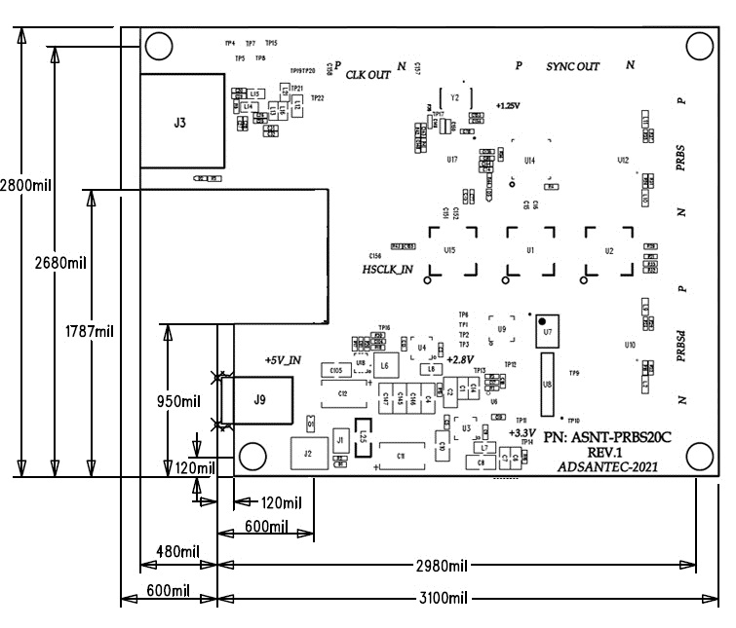
Fig. 5 Board Dimensions Diagram

REVISION HISTORY
Revision | Date | Changes
1.1.2 | 11-2024 | Updated for use with latest software features
0.1.2 | 08-2024 | Preliminary Release

